Computer Networks 1
Lab 8
TCP with Wireshark

Name:

Student no.: ……………………………..

I. Objectives
- Analyze TCP behaviors in reality.
- Investigate how TCP uses sequence and acknowledgement numbers
- Examine how TCP control congestions: slow start, congestion avoidance
- Investigate TCP flow control, connection establishment, throughput computation and round trip time
II. Content
1. Capture a large number of TCP segments transferred from your computer to a remote host:
You will need to use Wireshark for this task. Try to get access to a website that allows you to upload a file from your computer using HTTP POST method (e.g: vre.cse.hcmut.edu.vn/portal). Use Wireshark during this upload time to capture TCP segments that come in and out of your computer. You can step by step follow the following instructions:

- Use your Web browser to access http://gaia.cs.umass.edu/wireshark-labs/alice.txt to get a copy of “Alice in Wonderland”. Save this file in your computer.
- Open this page: http://gaia.cs.umass.edu/wireshark-labs/TCP-wireshark-file1.html, you will see a screen similar to Figure 1.
- Using Browse button to select the file that has the story “Alice in Wonderland” you have just saved.
- Open Wireshark and start capturing.
- Go back to the browser and select upload option to start uploading file to the server. Once the file has been uploaded successfully, a message will be displayed in your browser.
- Stop capturing in Wireshark. Your Wireshark window will be similar to Figure 2.

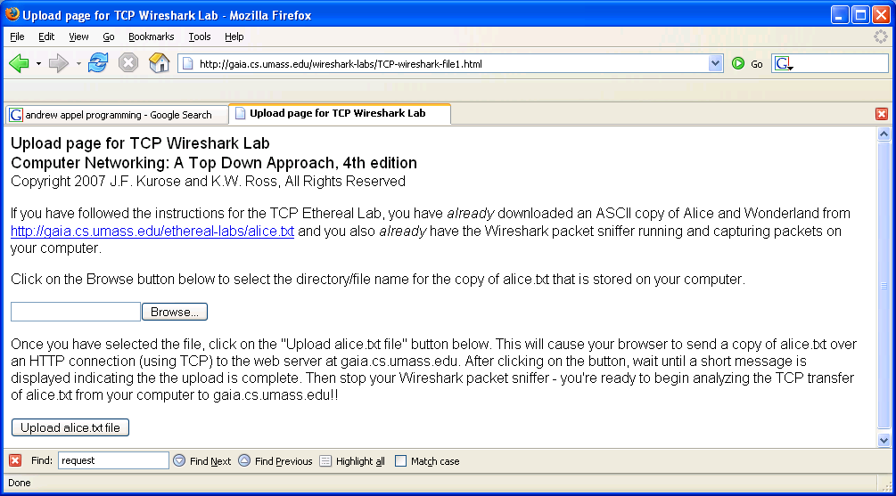
Figure 1. The test webpage shown in browser

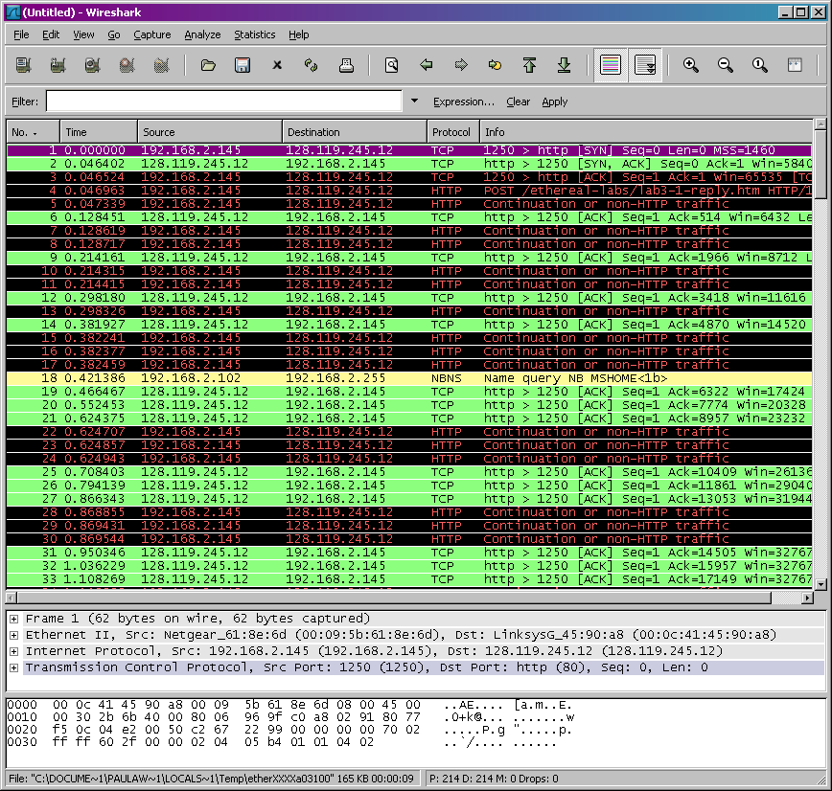

Figure 2. Wireshark window after stoping capturing

2. First look to TCP segments
Before analyzing TCP behaviors, let’s have an overall view of TCP segments. You can use the filter of Wireshark to only display TCP related packets, by entering tcp to the filter’s text box. You will then see a lot of TCP segments and HTTP messages transferred between your computer and the remote server. You will notice that TCP segments used for three ways handshake contains SYN message. You will also see HTTP POST and “HTTP continuation” messages sent from your computer to gaia.cs.umass.edu. Recall to your last lab exercise, “HTTP continuation” messages did not appear. This is the way that Wireshark points out that there are many TCP segments used to carry a HTTP message. You will also notice TCP ACK segments returned from the remote server.

As your exercises: download the file identified by this URL: gaia.cs.umass.edu/wireshark-labs/wireshark-traces.zip and answer the following questions:
- What were the IP address and the TCP port used by the client computer while uploading a file to gaia.cs.umass.edu?
- What was the IP address of gaia.cs.umass.edu? Which port number was used by the server for transferring TCP segment?
- What port number and IP address were used by your computer to upload the file to the remote server?
To display only segments of TCP protocol, go to Analyze option on the menu and select Enableed Protocols and then uncheck HTTP in the protocol list, then select OK. Wireshark window will be similar to Figure 3.

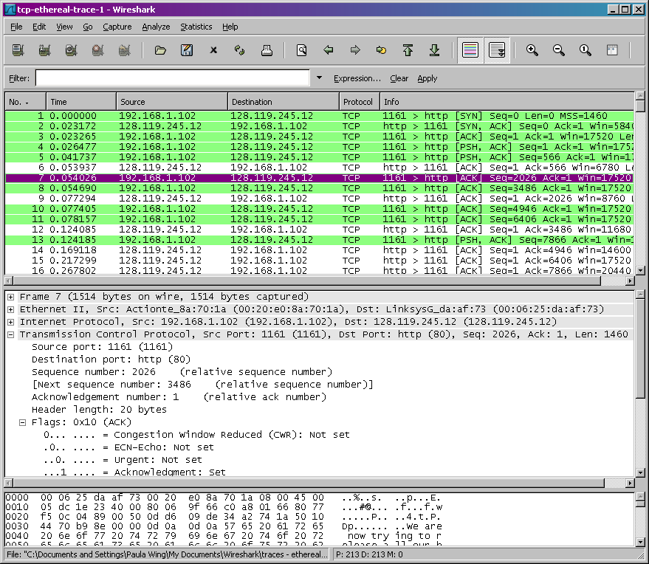
Figure 3. Wireshark window after unselect HTTP protocol

3. TCP basic concepts

Answer the following questions about TCP segments:
- What was the sequence number of TCP SYN that was sent to initiate the connection between your computer and remote server? Which field of the segment told that the segment was a SYN segment?
- What was the sequence number of TCP SYNACK segment that was sent by gaia.cs.umass.edu to respond to SYN segment? What was the value of ACK field of SYNACK segment? How gaia.cs.umass.edu defined this value? Which field of the segment let us know that it was a SYNACK segment?
- What was the sequence number of TCP segment that contained HTTP POST commands? Try to look into contents of TCP segments to identify POST commands.
- Examine TCP segments that contained HTTP POST commands. These were among the first segments that were sent out after the connection had been established. What were the sequence numbers of the first six TCP segments? At what time these segments were sent? When was the ACK for each segment received? Calculate the round trip time for these six segments by comparing the time that the segments were sent and the ACKs were received. What was the EstimatedRTT after each ACK segment was received? Try to compare the values you calculated and the knowledge you learned from the lectures.
Wireshark provides a function for plotting RTT for each TCP segment sent out. Select a TCP segment that was sent from your computer to the remote server, then select Statistics->TCP Stream Graph->Round Trip Time Graph.
- What was the length of each of the six segments?
- What was the size of available space of the receiving buffer that was sent to the receiver in the whole process? How did the lack of receiving buffer affect the sending speed of the sender?
- Was there any segment that was resent?
- How many bytes of data were acknowledged by the receiver in an ACK segment?
- What is the throughput of a TCP segment? How to calculate this value?

4. TCP congestion control in reality
Let’s examine the amount of data that was sent in a unit of time from the client to the server. Instead of using raw data from Wireshark window for calculation, let’s use utilities provided by Wireshark (by using Stevens graphs).
Select a TCP segment in Wireshark packet list. Select from the menu: Statisitics->TCP Stream Graph->Time-Sequence Graph (Stevens), you will see a graph similar to Figure 4.

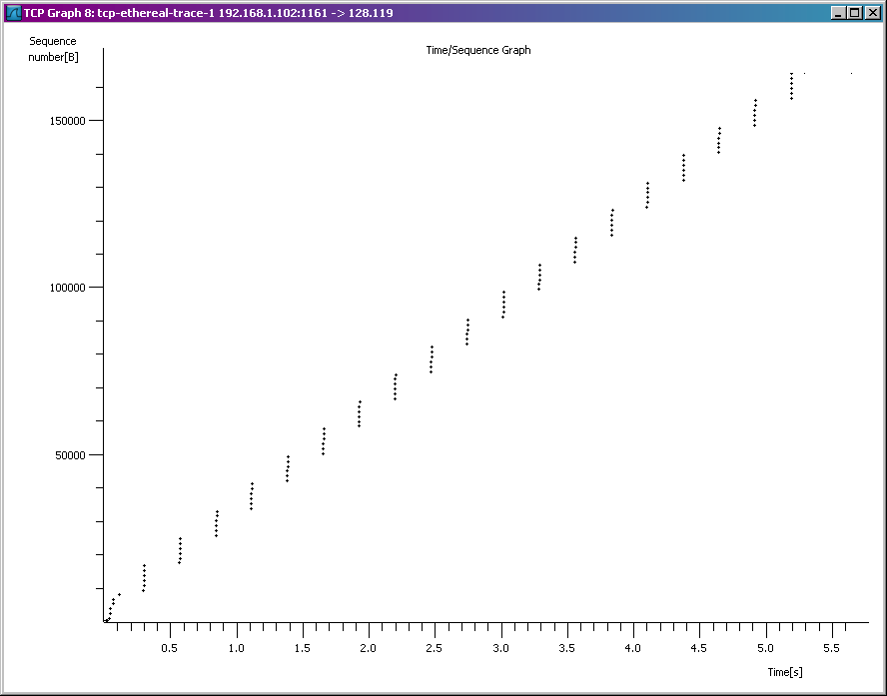
Figure 4. Sequence number graph over time (Stevens)

In this graph, a dot represents a TCP segment. The graph shows the sequence number of the segment and the time that the segment was sent. Note that a group of dots that stacked on together shows that the segments were sent out contiuously back to back by the sender.
Answer the following questions:
- Using Time-Sequence Graph – Stevens to compare the distribution of sequence numbers the segments and the time that these were sent from the client machine to the server gaia.cs.umass.edu. Can you identify the time that Slow start mode started and stopped? And the time that Congestion avoidance mode started? Compare and discuss the difference between the real data computed by using Wireshark and the ideal model of TCP shown in textbook.

